TWO WAY COMMUNICATION

Prepare the new app in the angular with name parent

* ng new parent

prepare the component called child

* ng g c child

COMMUNICATION FROM **PARENT** TO **CHILD**

GOTO>app.component.html and below code

<h1>Component Level Interaction</h1>

<h2>Two Way bindings</h2>

<app-child ></app-child>

Start the app

* ng serve

goto>app.component.html

<hr>

<h3>Parent Component</h3>

<!--Parent to child communication-->

<input type="text" (keyup)="0" #ptext>

<app-child [pdata]="ptext.value"></app-child>

Goto>child.component.ts file

import { Component } from '@angular/core';

@Component({

  selector: 'app-child',

  templateUrl: './child.component.html',

  styleUrls: ['./child.component.css'],

  inputs:['pdata']

})

export class ChildComponent {

  pdata:string="";

  constructor(){}

  ngOnInit():void{

  }

}

**Goto>Child.component.html** file

<p>child works!</p>

<br>

<p>Value coming from Parent Component:<b>{{pdata}}</b></p>

Save and check the output

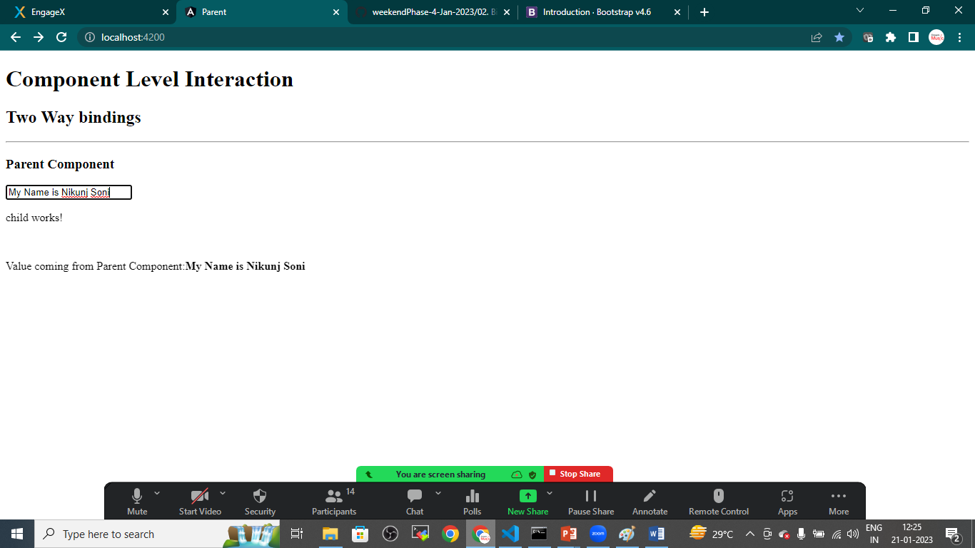

CHILD TO PARENT COMMUNICATION

Goto>child.component.html

<p>child works!</p>

<br>

<p>Value coming from Parent Component:<b>{{pdata}}</b></p>

<!--Child to Parent Communication-->

<input type="text" #cdata (keyup)="onChange(cdata.value)">

Child.component.ts

import { Component, EventEmitter } from '@angular/core';

@Component({

  selector: 'app-child',

  templateUrl: './child.component.html',

  styleUrls: ['./child.component.css'],

  inputs:['pdata'],

  outputs:['cevent']

})

export class ChildComponent {

  pdata:string="";

  constructor(){}

  ngOnInit():void{

  }

  cevent= new EventEmitter<String>();

  onChange(value:string){

    this.cevent.emit(value);

  }

}

Goto>app.component.html

<h1>Component Level Interaction</h1>

<h2>Two Way bindings</h2>

<hr>

<h3>Parent Component</h3>

<!--Parent to child communication-->

<input type="text" (keyup)="0" #ptext>

<!--Child to parent communication-->

<p>Value coming from child: <b>{{cdata}}</b></p>

<app-child [pdata]="ptext.value" (cevent)="cdata=$event"></app-child>

Goto>app.component.ts

import { Component } from '@angular/core';

@Component({

  selector: 'app-root',

  templateUrl: './app.component.html',

  styleUrls: ['./app.component.css']

})

export class AppComponent {

  title = 'parent';

  cdata:String="";

}

Save it and check the output

